# What is Ensemble Learning?

**Definition:**  
Ensemble Learning is a machine learning technique where multiple models (called base learners or weak learners) are combined to produce a stronger and more accurate predictive model.

“One model may make some mistakes, but if we combine several different models, their collective decision is usually more accurate.”

**Why we use it:**

* To **reduce errors** (better accuracy)
* To **reduce overfitting** (better generalization)
* To **improve robustness** (more stable predictions)
* To **combine the strengths** of different models

## Real-life Analogy

Suppose you want to predict tomorrow’s weather.

You ask 3 weather experts, each giving slightly different predictions.

If you average their predictions or go with the majority, your final prediction is often more accurate than any single expert’s opinion.

That’s ensemble learning in action!

# Types of Ensemble Learning

|  |  |  |
| --- | --- | --- |
| **Type** | **Description** | **Example** |
| **Bagging** | Builds multiple independent models in parallel on random data subsets | Random Forest |
| **Boosting** | Builds models sequentially; each new model corrects the previous model’s errors | AdaBoost, XGBoost |
| **Stacking** | Combines predictions from different models using another model (meta-learner) | Model stacking in competitions |

# Bootstrapping

**Bootstrapping** is a **data sampling technique** used in ensemble methods like bagging.

**Process:**

* From a dataset of size *N*, we randomly sample *N* data points **with replacement**.
* So, some data points may appear multiple times; some may not appear at all.

**Purpose:**

* To create **diverse training subsets** so that each model learns slightly different patterns.

**Example:**  
You have 1000 rows in your dataset.  
For each model in your ensemble:

* You draw 1000 rows **randomly with replacement**.
* So model A, B, and C may train on slightly different versions of your dataset.

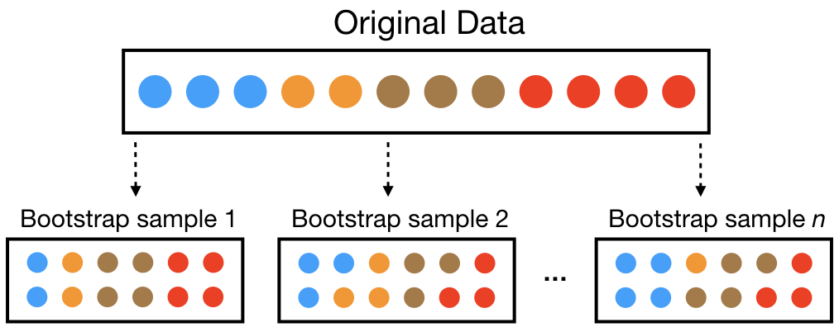

# Bagging (Bootstrap Aggregating)

**Bagging = Bootstrapping + Aggregation**

**Goal:**  
Reduce **variance** (overfitting) by averaging multiple independent models trained on different subsets.

**How it works:**

* **Step 1:** Multiple subsets are created from the original data set with equal tuples, selecting observations with replacement.
* **Step 2:** A base model is created on each of these subsets.
* **Step 3:**Each model is learned in parallel with each training set and independent of each other.
* **Step 4:**The final predictions are determined by combining the predictions from all the models.

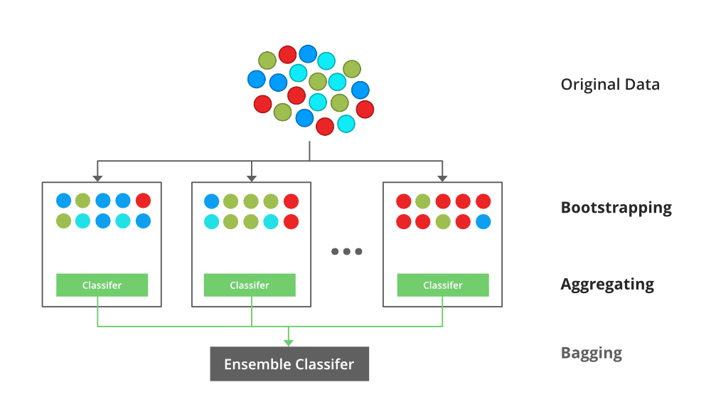

**Example:**  
Suppose we train 5 Decision Trees on bootstrapped subsets:

* Tree 1 predicts: 0
* Tree 2 predicts: 1
* Tree 3 predicts: 1
* Tree 4 predicts: 0
* Tree 5 predicts: 1  
  **Final prediction (majority vote):** 1

**Model Example:**  
**Random Forest** is the most popular Bagging algorithm.  
It builds many decision trees using bagging and averages their results.

# Boosting

**Boosting** is a **sequential** ensemble technique models are trained one after another, and each new model tries to **correct the errors** made by the previous ones.

**Goal:**  
Reduce **bias** (improve accuracy) by focusing on **hard-to-predict samples**.

**How it works:**

1. Train a weak model (e.g., a shallow decision tree).
2. Increase the weights of misclassified points (so the next model focuses more on them).
3. Train the next model on this reweighted data.
4. Continue until a certain number of models are trained.
5. Combine them (weighted sum of predictions).

**Example:**

* Model 1 misclassifies 20% of data.
* Model 2 focuses on those 20%.
* Model 3 focuses on the remaining misclassified ones.

Each model **learns from the mistakes** of the previous ones.

# What is Stacking (Stacked Generalization)?

**Definition:**  
Stacking (short for *Stacked Generalization*) is an ensemble learning technique that combines predictions from multiple different models using a meta-model (or blender) to produce a final output.

In simpler terms:

Instead of combining models by averaging (like in bagging) or sequential correction (like in boosting), stacking trains another model to learn how best to combine the predictions of several base models.

**Why Do We Use Stacking?**

Because no single model performs best on every dataset — some capture linear patterns, some nonlinear ones.  
Stacking leverages the **strengths of different models** to get a better overall prediction.

**Benefits:**

* Can combine *different types* of models (Decision Trees, SVMs, Neural Networks, etc.)
* Reduces both **bias and variance**
* Often gives **the best performance** in competitions like Kaggle

**How Stacking Works (Step-by-Step)**

Let’s break it down clearly:

**Step 1: Base Learners**

You train several different models (called **Level-0 models**), e.g.:

* Model 1: Decision Tree
* Model 2: Logistic Regression
* Model 3: K-Nearest Neighbors

Each model gives predictions on the same training data.

**Step 2: Meta Learner**

Then you train a **new model (Level-1 model)** on the **predictions of the base models**.

This model learns **how to weight or combine** the outputs of the base learners.

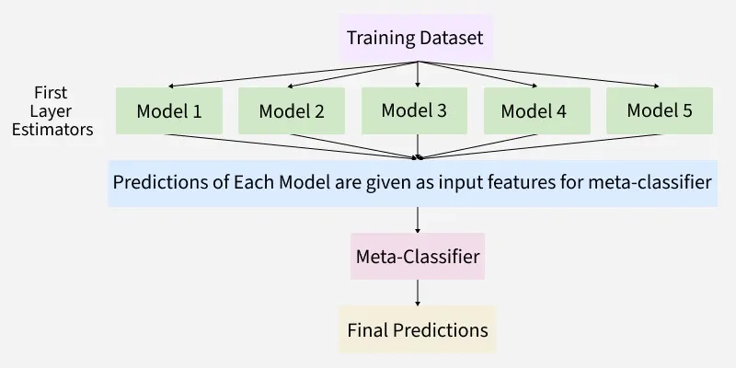

**Example:**

* Model 1 predicts: 0.8
* Model 2 predicts: 0.6
* Model 3 predicts: 0.9
* True label: 1

The meta-model learns that combining these (say, 0.7 average or a logistic regression combination) gives a better final decision.

**Real-Life Analogy**

Imagine you want to predict a house price:

* **Model A (Linear Regression):** Focuses on overall trend
* **Model B (Decision Tree):** Captures nonlinear jumps
* **Model C (KNN):** Catches local patterns

Now, you take all three predictions and feed them to a **meta-model**, say a Logistic Regression, which learns:

“If A predicts high and B predicts medium, trust A more.”

This combination often beats any single model alone.

# AdaBoost (Adaptive Boosting)

**Concept**

* **AdaBoost** is the **first successful boosting algorithm**.
* It builds a **sequence of weak learners** (usually *shallow Decision Trees*, called **stumps** trees with just one split).
* Each new model **focuses on the mistakes** made by the previous models.

**Goal:**  
Improve accuracy by giving **more weight to the misclassified samples** so that the next model focuses on them.

**How It Works**

1. Start with all data points having **equal weights**.
2. Train a weak learner (like a small decision tree).
3. Increase the weights of **misclassified points** so the next learner pays more attention to them.
4. Train another weak learner on the re-weighted data.
5. Repeat this process.
6. Final prediction = **weighted sum** of all learners.

**Example Intuition**

Imagine a classroom where the teacher asks 10 questions:

* Student (model 1) gets 6 correct, 4 wrong.
* Teacher gives **extra practice** on those 4 wrong ones.
* Student improves and does better next time.  
  Each round (learner) improves on the previous one’s mistakes — that’s boosting.

**Python Example (AdaBoost)**

from sklearn.ensemble import AdaBoostClassifier

from sklearn.tree import DecisionTreeClassifier

from sklearn.datasets import load_iris

from sklearn.model_selection import train_test_split

# Load data

X, y = load_iris(return_X_y=True)

X_train, X_test, y_train, y_test = train_test_split(X, y, random_state=42)

# Weak learner: Decision Stump

base = DecisionTreeClassifier(max_depth=1)

# AdaBoost

ada = AdaBoostClassifier(base_estimator=base, n_estimators=50, learning_rate=1.0)

ada.fit(X_train, y_train)

print("AdaBoost Accuracy:", ada.score(X_test, y_test))

# 2. XGBoost (Extreme Gradient Boosting)

**Concept**

* **XGBoost** is an **improved version of Gradient Boosting** — it’s faster, more efficient, and less prone to overfitting.
* It uses **gradient descent optimization** to minimize the overall error.
* It includes **regularization (L1 and L2)** to make the model more generalizable.

**Goal:**  
Optimize both **accuracy and speed** with better control over model complexity.

**How It Works**

1. Train an initial model (like a small decision tree).
2. Compute the **residuals (errors)** between actual and predicted values.
3. Train the next model to predict these residuals.
4. Add this new model to correct the overall prediction.
5. Continue this process iteratively.

Each tree helps fix the mistakes of the previous ones **like a gradient descent in function space**.

**Why It’s Called “Extreme”**

Because it introduces several **engineering optimizations**:

* **Parallel computation**
* **Regularization (L1 & L2)**
* **Handling missing values automatically**
* **Early stopping**
* **Tree pruning**

**Python Example (XGBoost)**

from xgboost import XGBClassifier

from sklearn.datasets import load_iris

from sklearn.model_selection import train_test_split

X, y = load_iris(return_X_y=True)

X_train, X_test, y_train, y_test = train_test_split(X, y, random_state=42)

xgb = XGBClassifier(

n_estimators=100,

learning_rate=0.1,

max_depth=3,

subsample=0.8,

colsample_bytree=0.8

)

xgb.fit(X_train, y_train)

print("XGBoost Accuracy:", xgb.score(X_test, y_test))

# 3. CatBoost (Categorical Boosting)

**Concept**

* **CatBoost** is a **state-of-the-art gradient boosting algorithm** developed by **Yandex**.
* It is specifically designed to handle **categorical (non-numeric)** features **automatically**.
* It uses **ordered boosting** to reduce overfitting and improve accuracy.

**How It Works**

* Uses **Gradient Boosting** like XGBoost but improves it:
  + Automatically encodes categorical features (no need for label encoding or one-hot encoding).
  + Uses **ordered boosting** (prevents target leakage).
  + Efficient, with fewer hyperparameters to tune.

**Example Intuition**

If you have a dataset with columns like:

* City = [“London”, “Paris”, “Berlin”]
* Weather = [“Sunny”, “Rainy”]

Traditional models need **encoding**, but CatBoost handles these **natively** — it learns from category statistics directly.

**Python Example (CatBoost)**

from catboost import CatBoostClassifier

from sklearn.datasets import load_iris

from sklearn.model_selection import train_test_split

X, y = load_iris(return_X_y=True)

X_train, X_test, y_train, y_test = train_test_split(X, y, random_state=42)

cat = CatBoostClassifier(iterations=100, learning_rate=0.1, depth=4, verbose=0)

cat.fit(X_train, y_train)

print("CatBoost Accuracy:", cat.score(X_test, y_test))